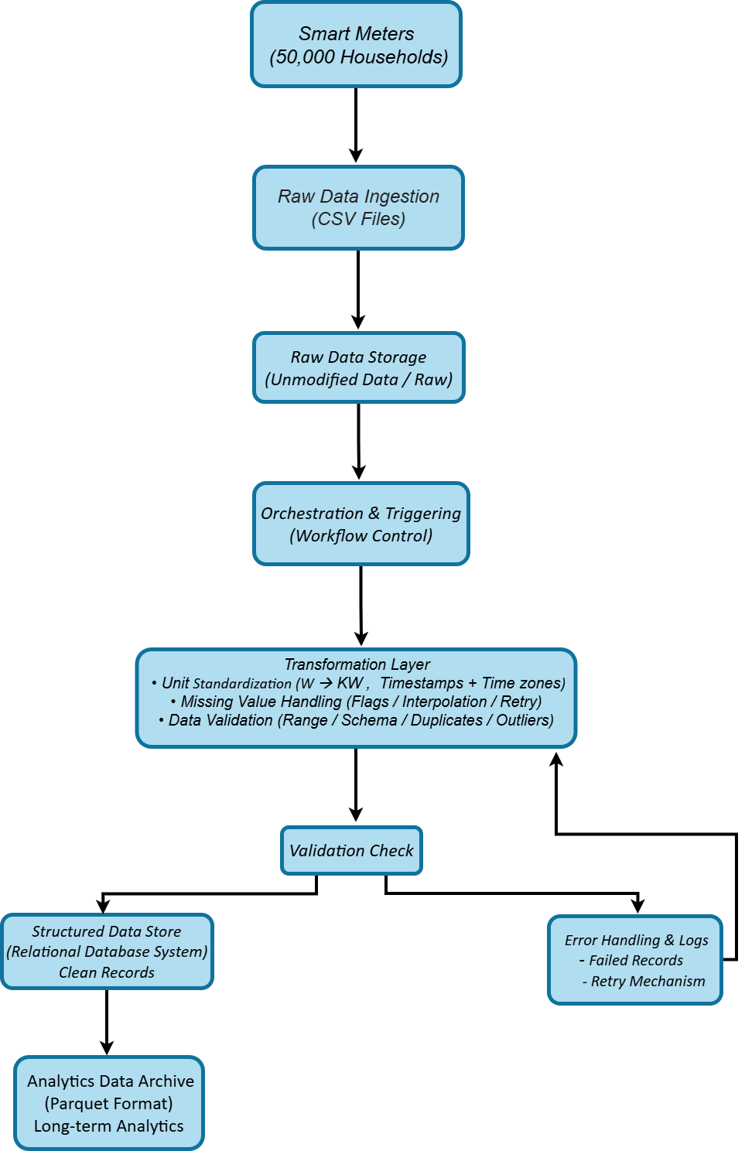
ETL Architecture for Smart Meter Data
ETL Pipeline Overview
• End-to-end data flow from raw ingestion to analytics-ready datasets
• Clear separation between raw, processed, and analytics layers
• Design emphasizes data quality, scalability, and fault tolerance
Data Ingestion and Raw Storage
• Smart meters generate periodic electricity consumption readings
• Data is ingested in CSV format
• Raw data is stored without modification for traceability
Orchestration and Transformation
• New data arrival triggers the processing workflow
• Energy readings are cleaned and standardized
• Validation rules ensure data consistency and reliability
Structured Storage and Validation
• Clean data is stored in a structured relational format
• Supports efficient querying and data quality monitoring
• Invalid records are isolated and logged
Analytics-Optimized Data Archive
• Data is converted into columnar format for analytics
• Optimized for historical analysis and forecasting
• Supports future machine learning workloads

Failure Handling and Reliability
• Automatic retry mechanisms handle temporary failures
• Error logs capture failed records
• Pipeline continues processing without interruption

Conclusion
• Raw smart meter data is transformed into analytics-ready datasets
• Data quality is enforced throughout the pipeline
• Design supports current analytics and future predictive use cases

